WEEK 5: RBAC + NSG + STORAGE
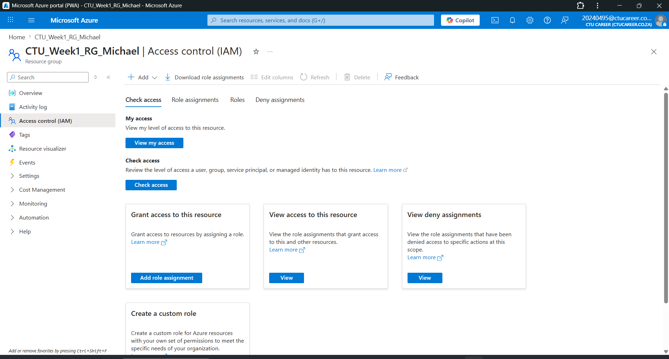

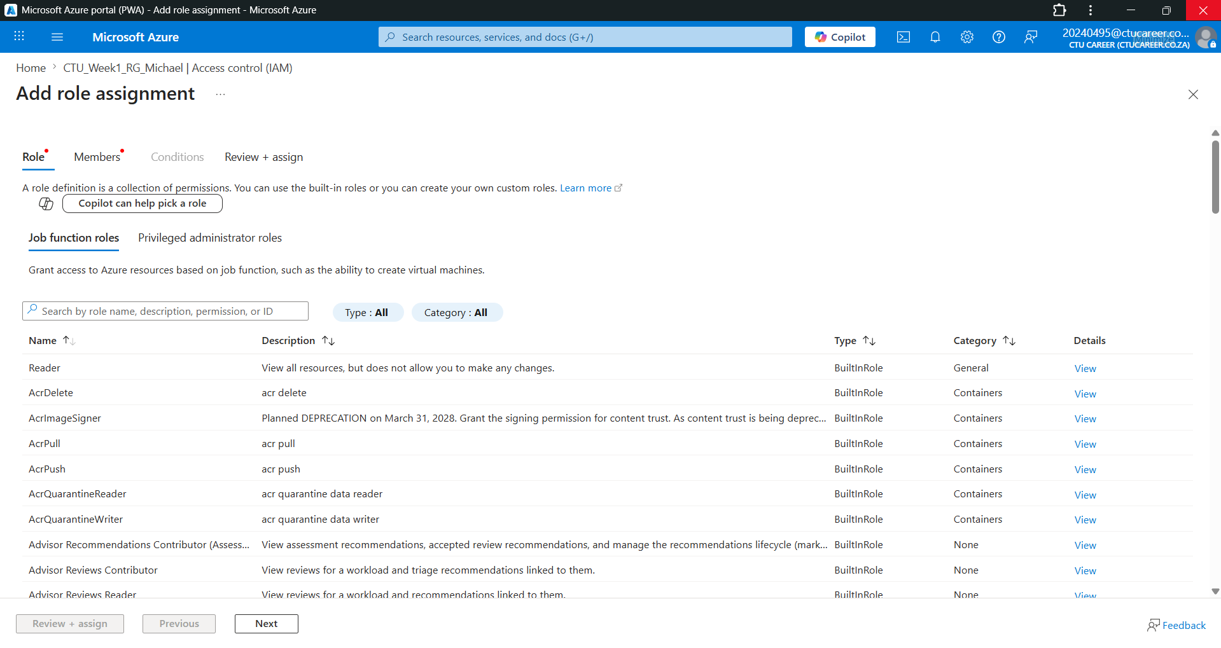

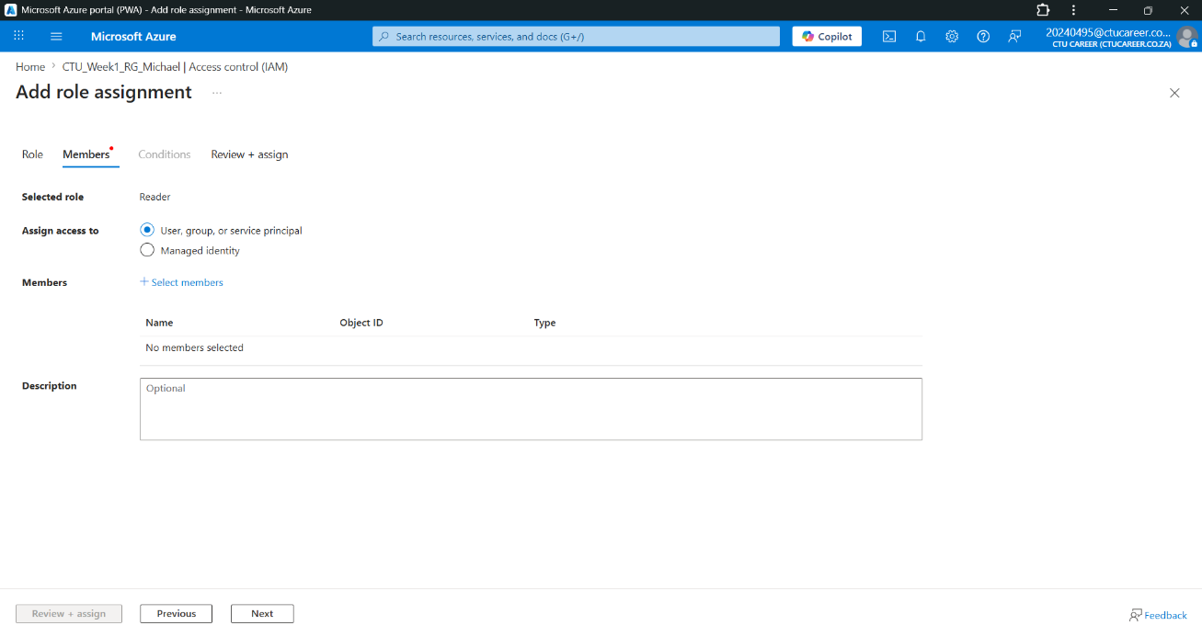
Do not have access to Microsoft Entra ID – therefore I cant create users.
- User1 → Reader
- User2 → Contributor
- You/Admin → Owner
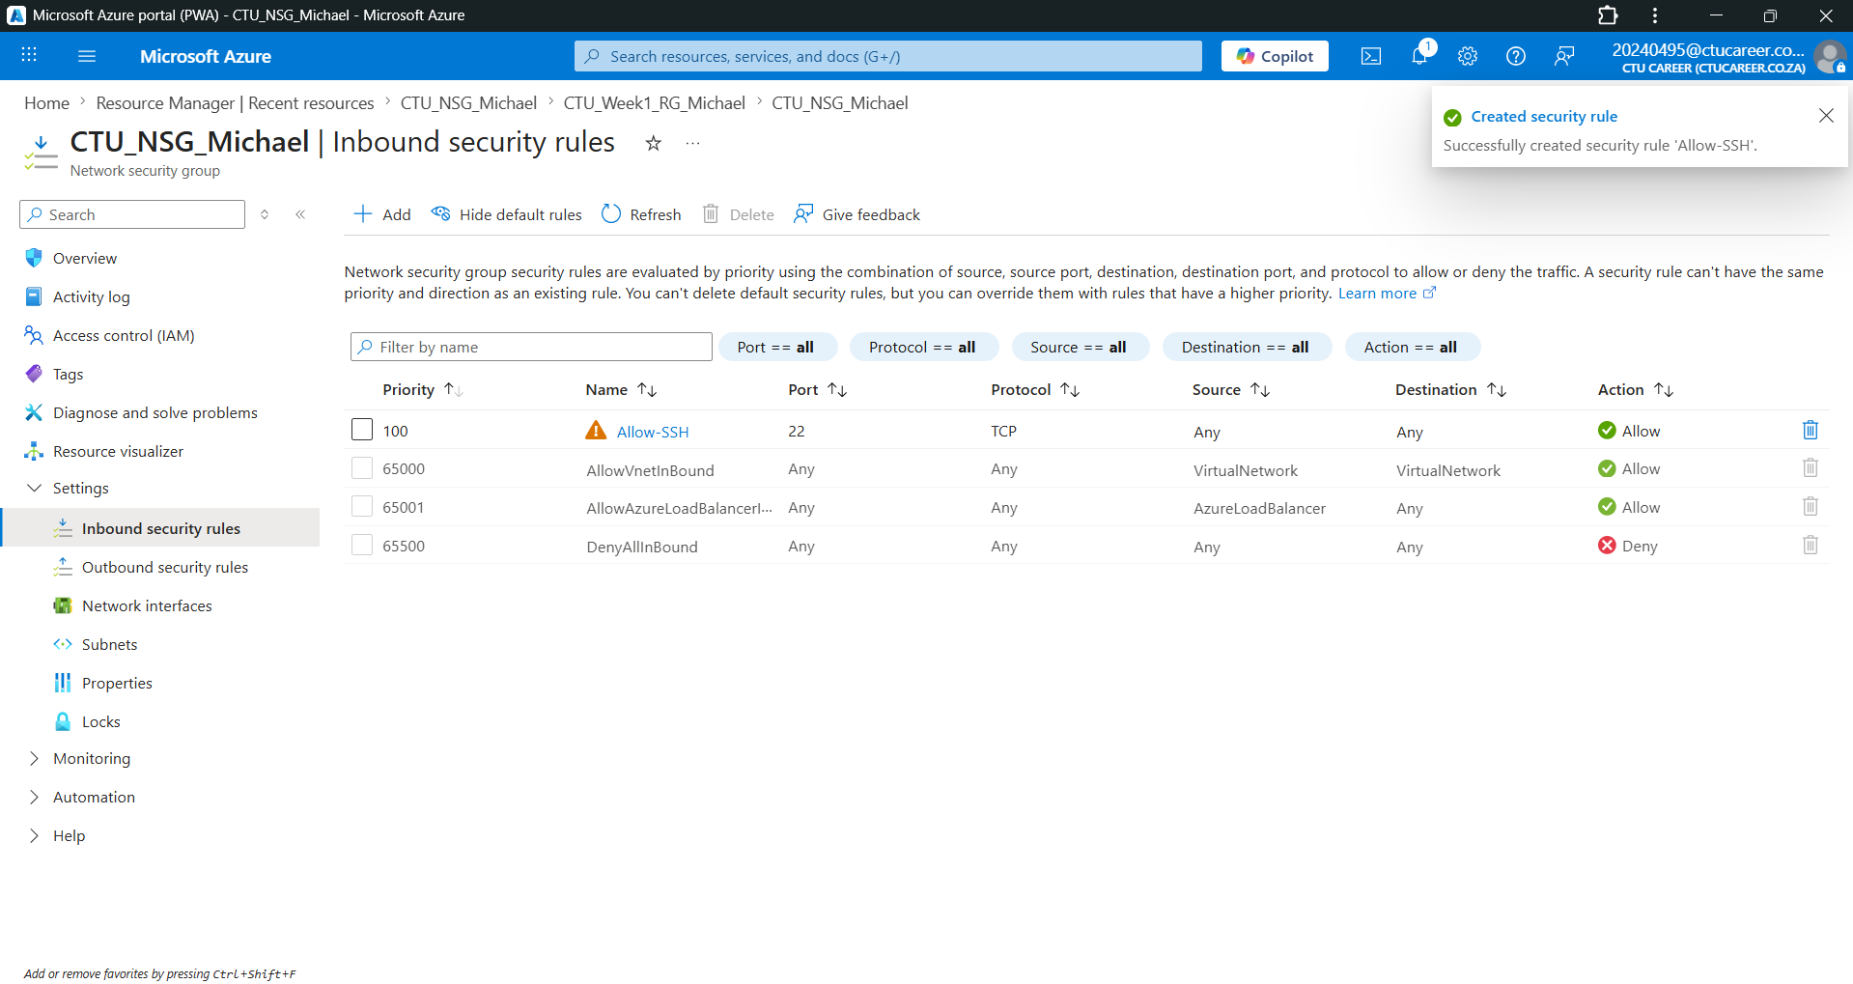

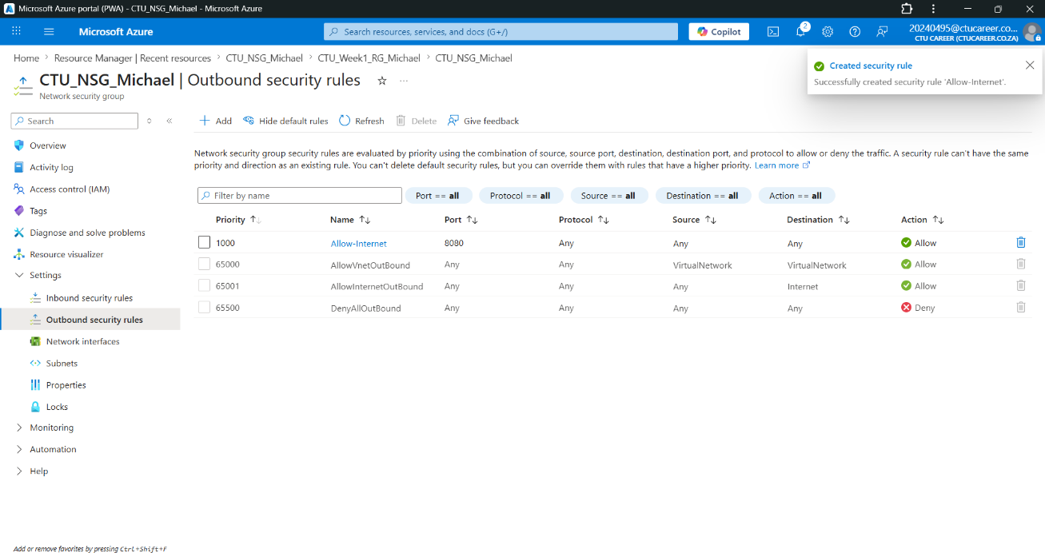

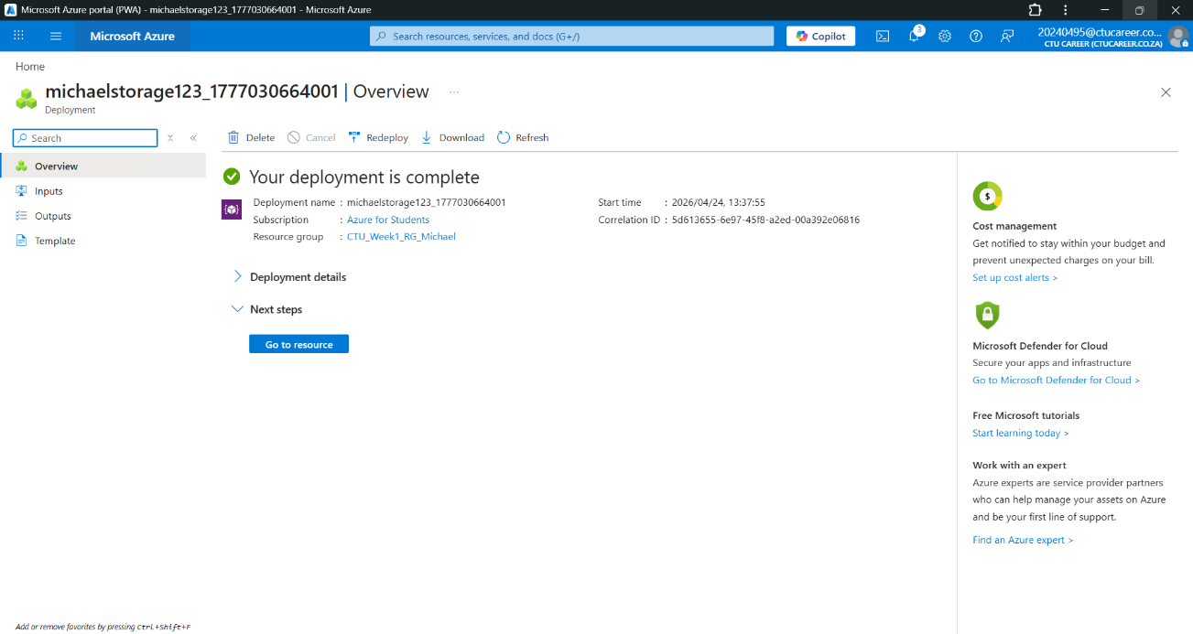

Storage Account created.
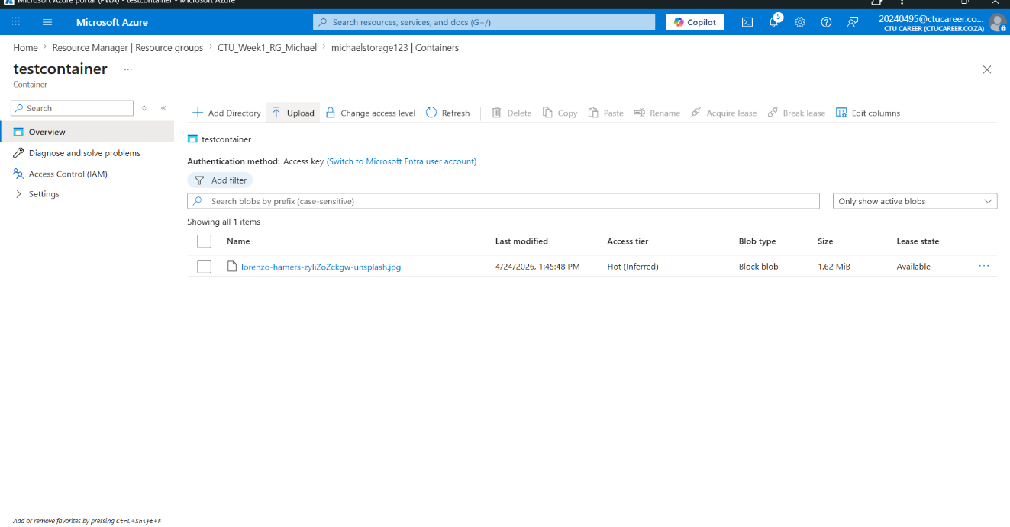

Container Created and file uploaded.

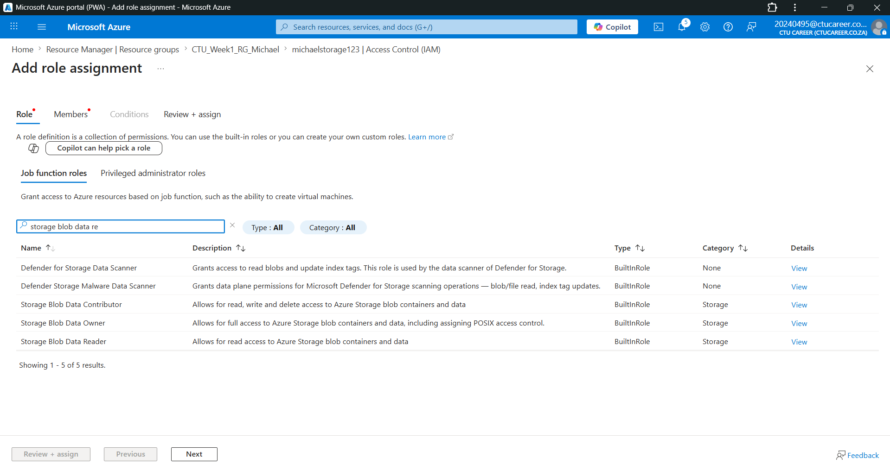

Part 1 (RBAC):
This step could not be completed because user creation in Microsoft Entra ID was not permitted. Therefore, role assignments were not performed.
Part 2 (NSG Configuration):
Inbound security rules were configured to allow access to the virtual machine using the appropriate port (SSH). Default outbound rules allowing internet access were reviewed.
Part 3 (Storage Account):
A storage account was successfully created using standard performance and locally redundant storage (LRS) within the same resource group.
Part 4 (Container & File Upload):
A private container was created, and a sample file was uploaded to demonstrate storage functionality.
Part 5 (Permissions):
Access control settings were reviewed, and storage permissions were configured where possible.

